Quiz#1 EDU601
1. Socrates believed that knowledge is the same thing as ------------- or excellence and is always good.
- Virtue
- Knowledge
- Faith
- Belief

2. Plato’s allegory of the cave can be seen as a metaphor for ---------------.
- The need to always adhere to conventional ideas
- The chaos of the imagination
- The search for the true and the good through philosophy
- The importance of prophecy

3. Who was the famous philosopher that came after Aristotle?
  - Socrates
  - There was none
  - Aristotle Jr.
  - Plato

4. The idea that “virtue is knowledge” is attributed to:
- Aristotle
- Plato
- Kant
- Socrate

5. Trying to understand human nature is:
- the work of ethics philosophers
- the study of what makes us human
- the discussion of differentiating humans from machines like computers
- is a metaphor for relating humans to other animals

6. What is the goal of education according to Idealism?
- Perfect adaptation to the environment
- Realizations of moral values
- Satisfaction of human wants
- Cultivation of dynamic, adaptable mind which will be resourceful and enterprising in all situations

7. According to Socrates, what is the lowest grade of cognitive activity?
- Imagination
- Belief
- Thought
- Confusion

8. According to Socrates, the ultimate knowledge is:
- Ordinary information
- Defining words & concepts
- One should learn best way to live life

9. What is the area of philosophy that investigates the nature, sources, limitations, and validity of knowledge?
- Deductive validity
- Epistemology
- Inductive strength
- Foundational belief

10. Epistemology is the study of ---------------.
- Reality
- knowledge
- book
- values

  - Doctrine means. Teaching
  - Who was one of the students of Socrates? Plato
  - The dialectic method crosses the divide line between matter and___. Idea
  - According to Socrates, the ultimate knowledge is: One should learn best way to live life
  - According to Socrates, what is the lowest grade of cognitive activity? Confusion
  - What philosophy is supposed to be? The truth of any claims is relative to the beliefs/ attitudes of the speaker.
  - Dialectic method is of: Socrates
  - Socrates believed that knowledge is the same thing as ___ or excellence and is always good. Virtue
  - A question-and-answer dialogue in which propositions are methodically scrutinized uncover the truth is known as ___. the Socrates method
Quiz#1 EDU601
1. Socrates believed that knowledge is the same thing as ------------- or excellence and is always good.
- Virtue
- Knowledge
- Faith
- Belief

2. Plato’s allegory of the cave can be seen as a metaphor for ---------------.
- The need to always adhere to conventional ideas
- The chaos of the imagination
- The search for the true and the good through philosophy
- The importance of prophecy

3. Who was the famous philosopher that came after Aristotle?
  - Socrates
  - There was none
  - Aristotle Jr.
  - Plato

4. The idea that “virtue is knowledge” is attributed to:
- Aristotle
- Plato
- Kant
- Socrate

5. Trying to understand human nature is:
- the work of ethics philosophers
- the study of what makes us human
- the discussion of differentiating humans from machines like computers
- is a metaphor for relating humans to other animals

6. What is the goal of education according to Idealism?
- Perfect adaptation to the environment
- Realizations of moral values
- Satisfaction of human wants
- Cultivation of dynamic, adaptable mind which will be resourceful and enterprising in all situations

7. According to Socrates, what is the lowest grade of cognitive activity?
- Imagination
- Belief
- Thought
- Confusion

8. According to Socrates, the ultimate knowledge is:
- Ordinary information
- Defining words & concepts
- One should learn best way to live life

9. What is the area of philosophy that investigates the nature, sources, limitations, and validity of knowledge?
- Deductive validity
- Epistemology
- Inductive strength
- Foundational belief

10. Epistemology is the study of ---------------.
- Reality
- knowledge
- book
- values

  - Doctrine means. Teaching
  - Who was one of the students of Socrates? Plato
  - The dialectic method crosses the divide line between matter and___. Idea
  - According to Socrates, the ultimate knowledge is: One should learn best way to live life
  - According to Socrates, what is the lowest grade of cognitive activity? Confusion
  - What philosophy is supposed to be? The truth of any claims is relative to the beliefs/ attitudes of the speaker.
  - Dialectic method is of: Socrates
  - Socrates believed that knowledge is the same thing as ___ or excellence and is always good. Virtue
  - A question-and-answer dialogue in which propositions are methodically scrutinized uncover the truth is known as ___. the Socrates method

1: Axiology is the study of…….? (Values) What is the state of reality? (Metaphysics)
3: Doctrine mean…………? (Teaching) 4: Plato defines the stages of curriculum according to age and types. These are………….?
(Elementary, Military, Higher education)
5: Kant system based on……..? Posteriori (systematic) and priori (analytic) logical judgements
6: The souls makes harm……..?
7 ……..is a pragmatist philosopher? John Dewey

Reminiscence means. (Recalling past )
▪ School founded by Aristotle known. (Lyceum )
▪ Main objective of dialectic method is to make decision. (Knowledge)
▪ Not considered in dialectic method. (Material knowledge )
▪ Plato’s aim in the republic. (To define justice and to prove that it is worthwhile to pursue its own sake )
▪ According to Kant, the basis of morality is the concept of: (Freedom )
▪ Kant claims that the moral law is given to each person by: (one’s own will)
▪ Plato defines the curriculum in which of the following three stages. Elementary, (Military, Higher Education)
▪ In what age range, the people would philosophies and would go up to the level of philosopher king? (Age 35 | 50)
  - Who were the three famous Greek Philosophers?(Socrates,Plato,Aristotle)
  - In Aristotle’s view, the virtue are: ( acquired through philosophical reflection)
  - How was the school founded by Aristotle known?(lyceum)
  - Epistemology is the study of …………..(knowledge)
  - Aristotle divides the virtue into: (moral virtues and intellectual virtues
The Allegory of the cave presents us with ………
(a metaphor for understanding the search for truth)
6.Who was the first famous philosopher of Greek philosophy?(Aristotle)
7. Rousseau was born ………….1712 (Geneva)
8Kant was influenced by the works of ……..who had put him on right track (Rousseau)
9.Kant claims that the moral law is given to each person by(one owns will)
10.According to Kant, the supreme principle (synthetic and priori
11.Accoding to ………..”Man can only become man by education.(Kant)
12.Kant was a …………..philosopher (German)
13.Who was the first philosopher to formulate logic for teaching procedures?(Aristotle
14.Aristotle claims that (virtue is our power, so is vice ))
15. Benjamin Bloom major work in is……….
16.obeying what feels good and reasonable and moral is type of obedience.
both(Absolute Obedience:Voluntary Obedience
plato philosophy of teaching method is id about using two teaching methods these methods are ………..and …..


EDU601 Quiz#2
Reminiscence means. Recalling past
School founded by Aristole known. Lyceum
Main objective of dialectic method is to make decision. Knowledge
Not considered in dialectic method. Material knowledge
Plato’s aim in the republic. To define justice and to prove that it is worthwhile to pursue its own sake
According to Kant, the basis of morality is the concept of: Freedom
Kant claims that the moral law is given to each person by: one’s own will
Plato defines the curriculum in which of the following three stages. Elementary, Military, Higher Education
In what age range, the people would philosophies and would go up to the level of philosopher king? Age 35 | 50

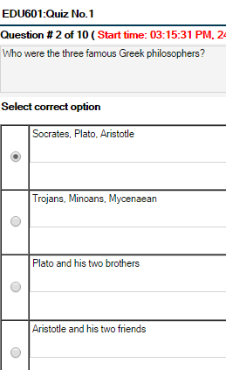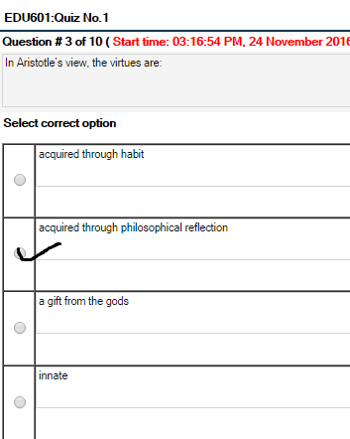
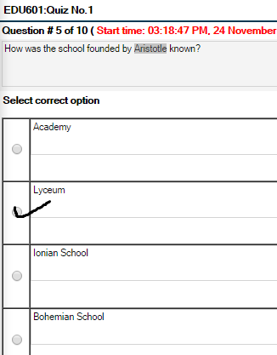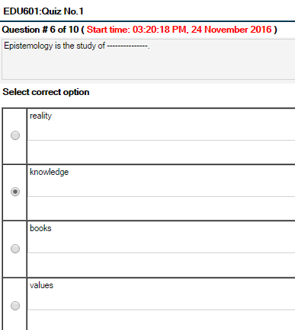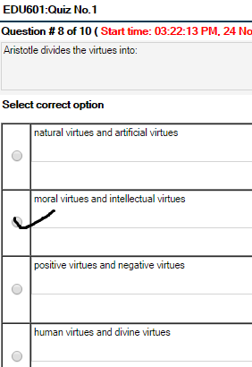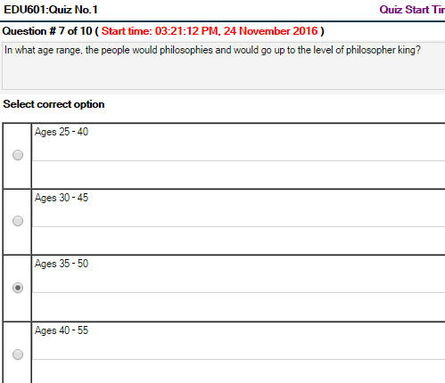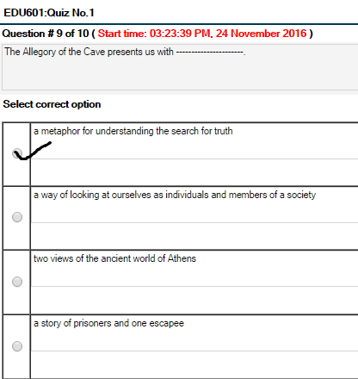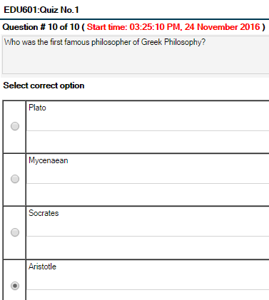
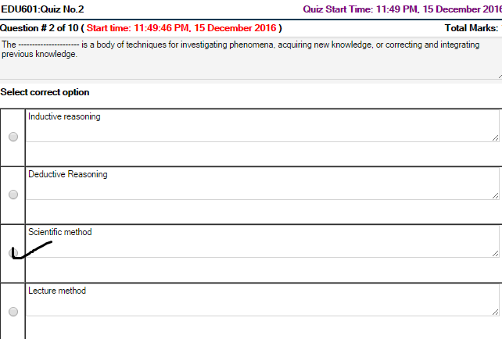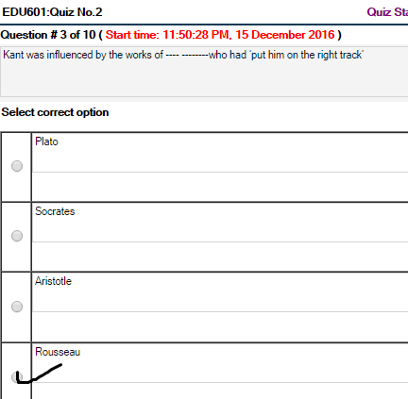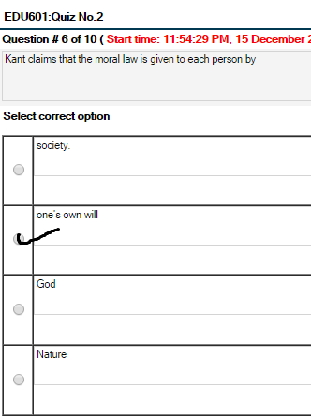
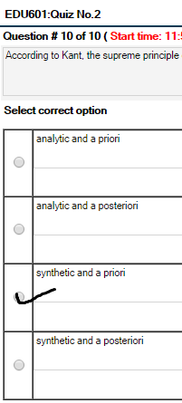
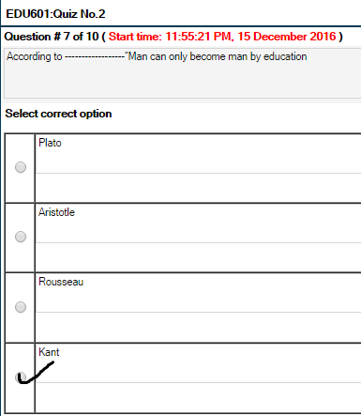
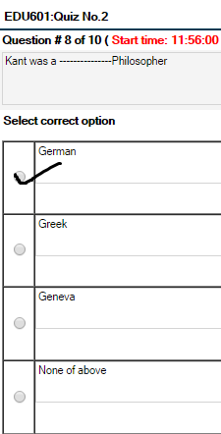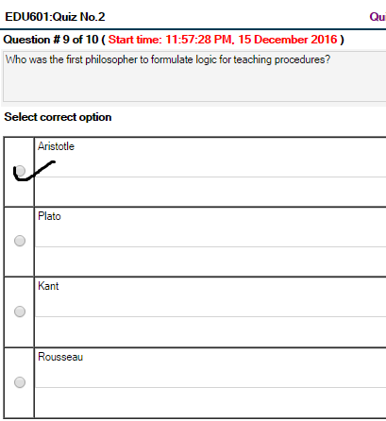
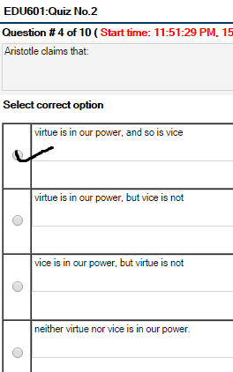
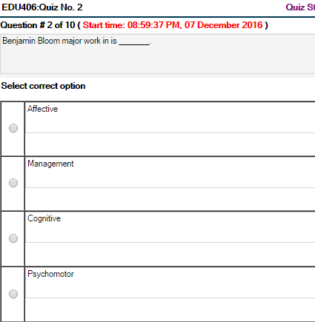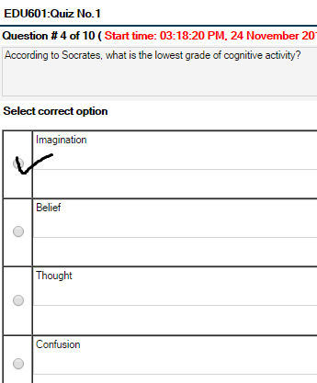

- Share, Support , follow, Subscribe!!!☺ or if u Need help me?
- Youtube: https://bit.ly/2t1P3Dd

